**Results**

**Spatial Variation in Diesel Ownership**

Figure Y displays the rate of diesel car ownership across the local authorities of the UK grouped by Government Office Regions of the UK. From this figure, it is apparent that the local authorities of Northern Ireland tend to contain higher proportions of diesel cars in their fleets compared to other regions. This observation indicates that a process is active in Northern Ireland that may be encouraging the ownership of diesel cars which is not present in the rest of the UK.

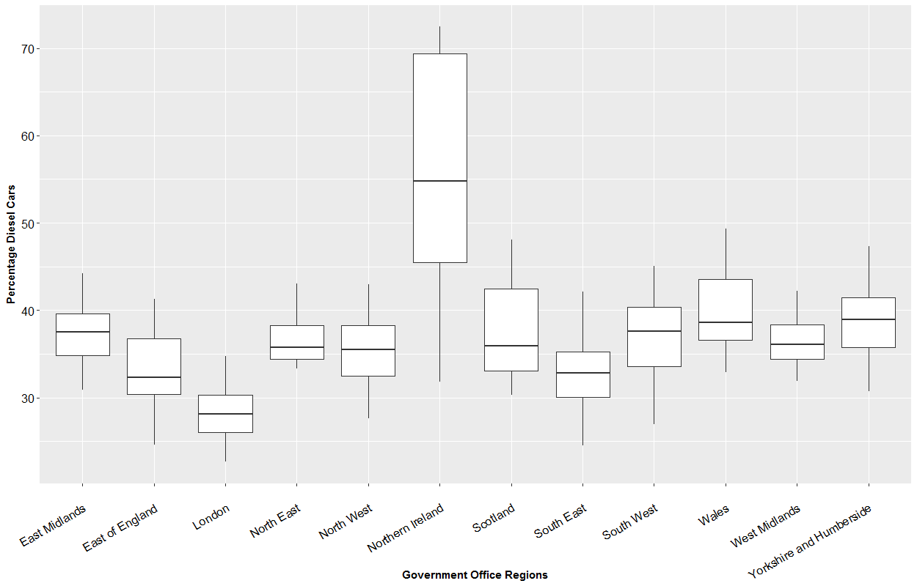

**Figure Y:** The percentage of a local authorities car fleet that is fuelled by diesel grouped by Government Office Region

Examining the spatial variation in diesel car ownership that is present within Northern Ireland, Figure Y illustrates the percentage of the car fleet which is diesel fuelled across the SOAs. In this figure, it is evident that spatial units that are closer to the border with the Republic of Ireland tend to display higher rates of diesel car ownership, with the rate diminishing as proximity to Belfast (the national capital located in the mid-east) increases.

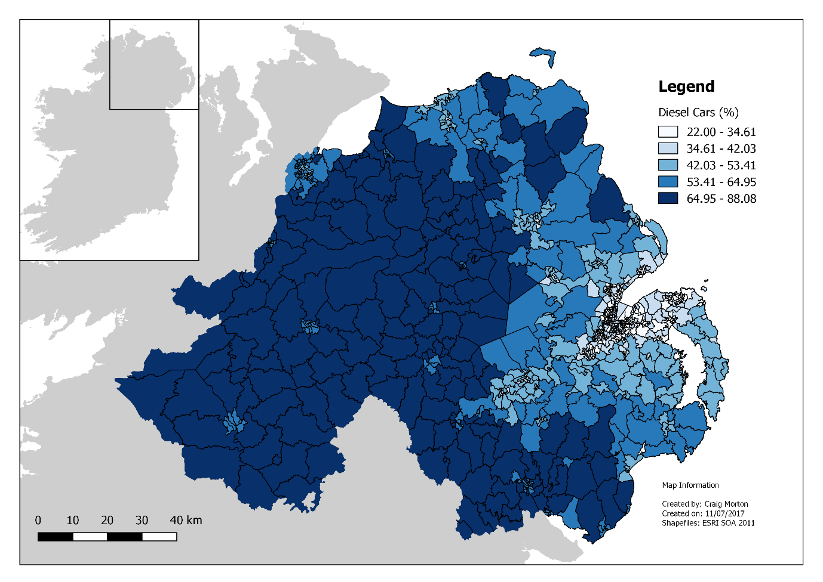

**Figure Y:** Choropleth map showing the proportion of the local car fleet that is diesel fuelled across the Super Output Areas of Northern Ireland

The spatial patterning in the rate of diesel car ownership also exhibits signs of spatial dependence, whereby the proportion of the car fleet which is diesel fuelled in one spatial unit is related to the proportion observed in neighbouring spatial units. This is supported by Moran’s-I test of spatial autocorrelation, which returns a strong positive coefficient (SYMBOL = 0.919, p-vale < .001). The occurrence of spatial dependence is clearly visible in the LISA analysis reported in Figure Y. Here, it is apparent that the border region of Northern Ireland, and extending a considerable distance inland, represents a hot-spot of diesel car ownership. Conversely, a cold-spot is present in the mid-east of the country and corresponds with the metropolitan area of Belfast.

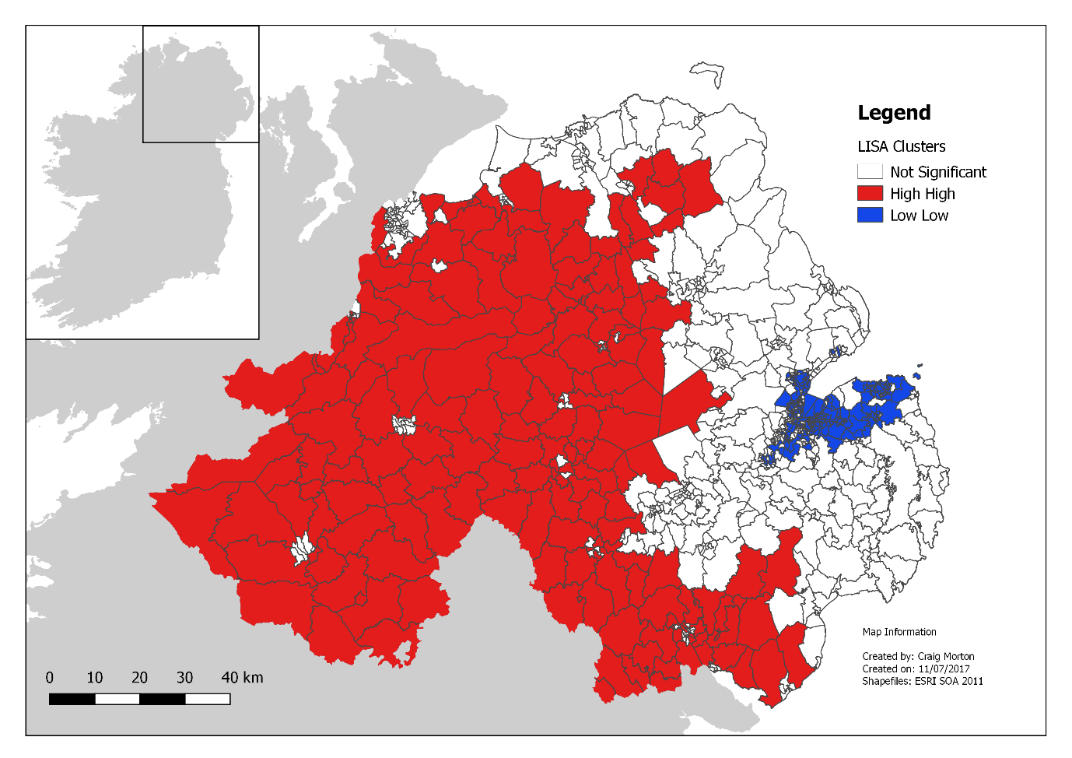

**Figure Y**: Local indicator of spatial association concerning the proportion of the local car fleet which is diesel fuelled

**Nearness to Border**

Figure Y displays the dispersion of the local car fleet that is fuelled by diesel across the border buffer groups of SOAs (i.e. the contiguity method). SOAs that intersect both a 5, 10, 15, and 20 km buffer with the border to the Republic of Ireland appear to have similar rates of diesel car ownership. This rate drops of noticeably for the SOAs that are outside of a 20 km buffer to the border (i.e. the rest of Northern Ireland), where the average rate of diesel car ownership is approximately 40%. The visible difference between the SOAs of the rest of Northern Ireland category and those assigned the buffer categories is supported by a significant Kruskal-Wallis test results (H = 335.929, p-value < .001).

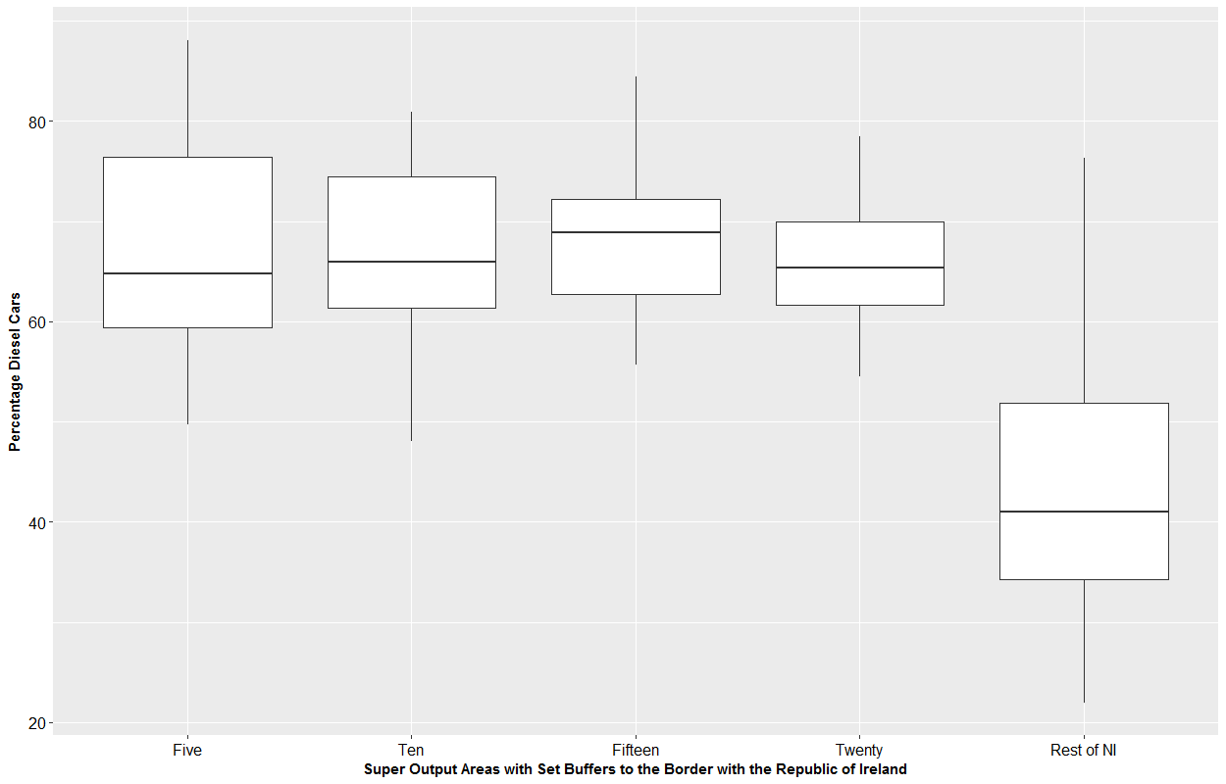

**Figure Y**: Boxplots grouping Super Output Areas by buffer to the border with the Republic of Ireland (i.e. the contiguity method) by the proportion of the car fleet that is fuelled by diesel

Figure Ya evaluates the relationship between diesel car ownership and Euclidean distance to the nearest road crossing into the Republic of Ireland (i.e. the proximity method). In this instance, a negative relationship is evident (rs: -0.713, p-value < 0.001), implying that as proximity to the border decreases, the rate of diesel car ownership tends to decrease. A similar set of findings is presented when considering network distance to the nearest fuel station in the Republic of Ireland (Figure Yb; rs: -0.598, p-value < 0.001) and network time to the nearest fuel station (Figure Yc, rs: -0.475, p-value < 0.001).

|  |  |  |
| --- | --- | --- |
|  |  |  |

**Figure Y:** Scatterplots of proportion of the Super Output Area car fleet that is diesel fuelled (y-axis) against (a) Euclidean distance to the nearest road crossing, (b) network distance to the nearest fuel station in the Republic of Ireland, and (C) network time to the nearest fuel station in the Republic of Ireland

**Regression Analysis**

The benchmark log-log OLS regression models, which have the proportion of the car stock which is diesel fuelled as the dependent variable, are reported in Table Y.

|  |  |  |  |  |  |
| --- | --- | --- | --- | --- | --- |
|  |  |  |  |  |  |
| Intercept | 4.293**  (0.342) | 4.580**  (0.275) | 6.007**  (0.276) | 6.277**  (0.277) | 5.259**  (0.272) |
|  |  |  |  |  |  |
| Mean Age | -0.147*  (0.072) | -0.172**  (0.058) | -0.180**  (0.056) | -0.187**  (0.056) | -0.170**  (0.057) |
| Self Employed | 0.047  (0.024) | 0.054**  (0.020) | 0.070**  (0.019) | 0.085**  (0.019) | 0.081**  (0.019) |
| University Degree | -0.094**  (0.019) | -0.087**  (0.015) | -0.101**  (0.015) | -0.116**  (0.015) | -0.126**  (0.015) |
|  |  |  |  |  |  |
| One Car | -0.062  (0.039) | -0.125**  (0.032) | -0.134**  (0.031) | -0.122**  (0.030) | -0.115**  (0.031) |
| Drive Commute | -0.164**  (0.039) | -0.110**  (0.032) | -0.118**  (0.031) | -0.118**  (0.030) | -0.112**  (0.031) |
| Over 30km Commute | 0.189**  (0.008) | 0.163**  (0.006) | 0.147**  (0.006) | 0.152**  (0.006) | 0.167**  (0.006) |
|  |  |  |  |  |  |
| Population Density | -0.048**  (0.006) | -0.040**  (0.005) | -0.046**  (0.004) | -0.048**  (0.004) | -0.047**  (0.004) |
| Mean Residents | 0.928**  (0.082) | 0.698**  (0.067) | 0.592**  (0.065) | 0.599**  (0.065) | 0.617**  (0.066) |
| Rent Social | 0.028**  (0.006) | 0.017**  (0.005) | 0.008  (0.005) | 0.008  (0.005) | 0.008  (0.005) |
|  |  |  |  |  |  |
| Flats | 0.008  (0.005) | 0.009*  (0.004) | 0.010**  (0.004) | 0.012**  (0.004) | 0.012**  (0.004) |
| 5km Buffer |  | 0.241**  (0.013) |  |  |  |
| 10km Buffer |  | 0.232**  (0.019) |  |  |  |
| 15km Buffer |  | 0.231**  (0.022) |  |  |  |
| 20km Buffer |  | 0.163**  (0.021) |  |  |  |
| Distance to Crossing |  |  | -0.107**  (0.004) |  |  |
| Network Distance to Fuel |  |  |  | -0.128**  (0.005) |  |
| Network Time to Fuel |  |  |  |  | -0.135**  (0.006) |